**ONLINE EXAMINATION SYSTEM**

**A PROJECT REPORT**

**Submitted by**

**MAZHARUL ISLAM**

**Roll : 1807102**

*Course no*

**CSE 2200**

*in*

**Department Of CSE**



**Khulna University Of Engineering & Technology**

**June 2021**

i

**CERTIFICATE**

Certified that this project report “Online Examination System” is the bonafide work of Mazharul Islam” who carried out the project work under my supervision.

|  |  |  |
| --- | --- | --- |
| **HM Abdul Fattah**  **Lecturer,CSE,KUET**  **GUIDE** | **Shunanda Das**  **Lecturer,CSE,KUET**  **GUIDE** | **Dr. Pintu Chandra Shil**  **Head of the Department**  **HEAD** |

**Department Of CSE**

**Khulna University Of Engineering & Technology**

ii

**ACKNOWLEDGEMENT**

I would like to express my special thanks of gratitude to my project guide HM Abdul Fattah, Lecturer, CSE, KUET sir and Shunanda Das, Lecturer, CSE, KUET sir as well as our HeadSir, Dr. Pintu Chandra Shil, Prof., CSE, KUET sir who gave me the golden opportunity to do this wonderful project on the topic Online Examination System, which also helped me in doing a lot of research and i came to know about so many new things I am really thankful to them.

Secondly I would also like to thank my parents and friends who helped me a lot in finalizing this project within the limited time frame.

|  |  |
| --- | --- |
| Date : 24-06-2021 | Name: Mazharul Islam |
| Place : Khulna, BD | Roll: 1807102 |
|  | BSc in Dept. of CSE |

iii

**TABLE OF CONTENTS**

|  |  |  |
| --- | --- | --- |
|  | **Online Examination System** |  |
|  | **ABSTRACT** | **I** |
| **1.0** | **OBJECTIVES** | **6** |
| **2.0** | **INTRODUCTION** | **7** |
| **3.0** | **IMPLEMENTATION** | **10** |
|  | 3.1 Hardware prerequisite |  |
|  | 3.2 Software prerequisite  3.3 Architectural Design  3.4 Actors  3.5 Database Schema Diagram |  |
| **4.0** | **DETAILED VISUALISATION** | **18** |
|  | 4.1 Login and Registration |  |
|  | 4.2 Student Profile  4.3. Admin Panel  4.4 Add MCQ Question  4.5 Add Written Question  4.6 Update and Delete Questions  4.7 MCQ Examination With Instant marks  4.8 Written Examination and Evaluate |  |
| **5.0** | **TARGET VS ACTUAL ACCOMPLISHMENTS** | **24** |
| **6.0**  **7.0**  **8.0** | **RISKS AND ISSUES**  **RESULTS AND DISCUSSION**  **CONCLUSION** | **25**  **26**  **27** |
|  | **REFERENCES** | **38** |

**ABSTRACT**

“Online Examination System” is a web based application totally focused on student’s progress

evaluation. As I’m studying in KUET, I experienced that manage and conduct examination for all

batches of all departments is a major headache for Examination Controller. So I decided to

design a platform with examination controller perspective with all rights like edit, create, update

and delete student’s information. This application is capable enough to save time of students

and faculty. “Online Examination System” not only replace paperwork but also release the

workload of faculty. “Online Examination System” give reliability, flexibility and robustness to

examination by modern computer technology

I

1. **Objectives**
2. **To use as alternative of Offline examination.**
3. **To reduce Paperworks .**
4. **To give and take exams effective and time effective.**
5. **To conduct examination process remotely.**
6. **To Evaluate Papers more efficiently and fastly.**
7. **To Reduce time difficulties and safety.**
8. **To Ensure Safety during pandemic.**
9. **INTRODUCTION**

**2.1 Introduction:**

“Online Examination System” refers to service as conduct online examination or test. It will use in Universities for students progress evaluation using modern computer technology. It replaced the paperwork and overcome the outcomes of traditional way of examinations using paper or pen. In education, the concept of E-Learning (Electronic Learning) has grown rapidly from distance learning to virtual classrooms towards the online courses and online examinations. Associations are trying to move from a paper-based environment to a paperless environment. People today through big and small tests, with test having become frequently faced issue. In addition, the testing system merits at being fair and open. With the increasing of Internet applications scope, computer net-assisted teaching is becoming a focus of current educational reform; online examination system because of its easy to use, time-intensive, forms and

other features has more attention . Online exam can improve the standards of student’s examination whereas in the traditional examination systems pen and paper are used which require more effort on the part of students and instructors. Online examinations are considered an important source for university exams . Moreover, the development of network technologies has given the possibility to deliver the exams online. Thus, education can benefit from these services. There are many benefits for adopting online examination system; some of essential, but not exhausted, involve: E-Learning remote exam ; Digital evolution ; Utilize available resources ; Supplementary and helpful for disabled people ; Ease of use and archive ; Clarity and credibility of check and grading ; Time saving especially in case of huge number of students ; and the beneficial effect of the E-Learning that made students break the barriers of the distance learning and expensive courses .

**2.2 Scope :**

• It is web based Desktop App which can be used by Admin or Students at any remote location.

• “Online Examination System” is fully developed automated system is to efficiently evaluate the candidate progress that not only save the time of Examination Controller and also gives fast result.

• The Administrator of the system has authority to propose tests or papers.

• It is cost effective and time effective.

• The candidate can login through proposed computer with their Enrollment number matching the details to the student’s database, then they can take the exam.

• Candidate can give their course’s examination in a specific duration and in specific number of questions.

• The questions can be appear in both mode MCQ (Multiple Choice Questions) and answer in paragraph.

**2.3 Users of OLES Users of OLES are classified into three categories:-**

• Administrator

• Test Conductor

• Student

**2.4 Problem Definition of Existing System :**

• Conductors required a long time to conduct examination in a traditional way. It is not possible to take examination of mass students.

• Examiners are not able to maintain the hard copy record of students in large quantity.

• For examiner, manipulation of student record is difficult.

• And have the problem of leaking the paper before examination but this problem will not born in online examination system.

**2.5. Problem Solution:**

After tackling with these problems, I feel that we need to create a virtual examination system because:

• It is easy to conduct.

• Give speed and accuracy to give examination and show result.

• Required less manpower to execute the examination.

• Save students and examiner’s time.

• It is cost effective and time effective.

• The questions are shuffled in a random order so that possibilities for getting questions in the same order for the students who are beside, is less.

**2.6 Benefit:**

The existing online examination systems present a set of features . These features are needed in order to make the functionalities of each online examination system meet their requirements to serve their purposes. The following subsections consider these features.

**2.6.1 Secure Login**

This feature means that login operation to access the system could not be done without authorization check. Furthermore, users should be registered for have authorization access. The authorization data to be checked are user name and password that specified for each user . Some system uses another authorization check such as test access restrictions by groups and Internet protocol (IP) addresses , student name and ID, matriculation number and password . In addition, other techniques are used to identify the user and check if the person who is logging into the system is the right person or not; various techniques are used like biometric authentication , fingerprint or face recognition via webcam.

**2.6.2 Multi-Instructor**

As the online examination system required being structurally solid, it should have multi-instructor feature. Therefore, each instructor has his/her own privileges and tasks. In order to achieve that, the system should consist of an administrator, question builder, and exam builder. The administrator manages and controls the system, and registers the instructors. Question builder, and exam builder are responsible for creating the questions, and exams respectively.

**2.6.3 Combination of Randomization**

The combination of randomization could be featured in online examination systems in three forms namely: random question selection, random questions distribution, and random choices distribution. The following subsections discuss each randomization feature individually.

1. **Implementation**

Before going to the architectural design, it is necessary to plan the design and selection of modules to be involved in the development. As the online examination requires software applied to works over a network in order to serve the function of remote exam, the OLES consists of hardware and software pre-requisites.

**3.1 Hardware Prerequisites**

1. Server and clients computers: server computer is the central computer to be connected to the other computers that act as clients.

2. Reliable network: the network connects the clients to the server needed to be active and to lower the chances of network failure and ease detect and recovery from a network failure. This implies that the organization should have a network infrastructure available.

**3.2 Software Prerequisites**

1. A server and clients OSs are required to work on the server side and client side respectively. In

addition, some administration setup is required to run the OLES in these machines.

1. Java programming language is proposed for concrete system implementation to realize the system. Thus, each client and server machine has a per-requisite of Java Runtime Environment (JRE) to be installed in the system. As such, the OLES supports cross-platform functionality . In addition, Derby distributed database management system is integrated with Java Oracles Eclipse IDE version 8.0.2, which facilitates the development of the whole product using available free tools for academic research using single development environment. .

**3.3 Architectural Design of Online Examination System**

The main portions of OLES are the server side and the client side. Server side consists of server

agent, database, Graphical User Interface (GUI), and network. Client side consists of client agent, temporary storage, GUI, and network. Server agent controls the OLES operation phases in the server side. Similarly, the client agent controls the OLES operation phases in the client side. The client and server agents play the protocol handlers International Journal of Computing Academic Research (IJCAR), Volume 4, Number 2, April 2015 of the system and connected via the network. Fig. 1 shows the system portions and interprets the control of both server agent and client agent.

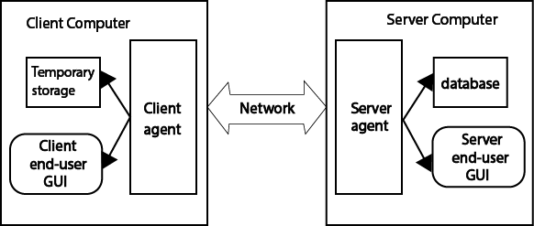

FIG : 1 system portions and interprets the control of both server agent and client agent.

**3.4 Actors in Online Examination System**

The proposed OLES performs different functions, these functions are executed by specific actors. The actors in OLES are :

i) Administrator,

ii) Instructors,

iii) Server agent,

iv) Client agent,

v) Students,

vi) Superintendent,

vii) Database and

viii) Temporary storage.

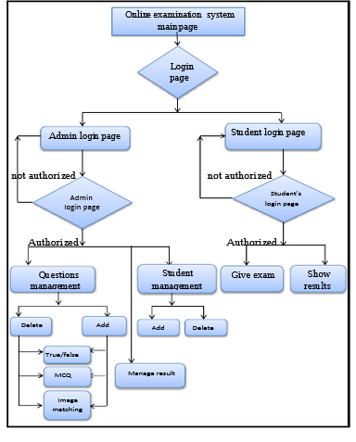

Fig: Flow chart Of Full Program

* + 1. **Administrator working Flow Chart:**

The Administrator and the Student interact with the Client Agent through a GUI. Similarly, the Administrator and the Instructor interact with the Server Agent through a GUI.

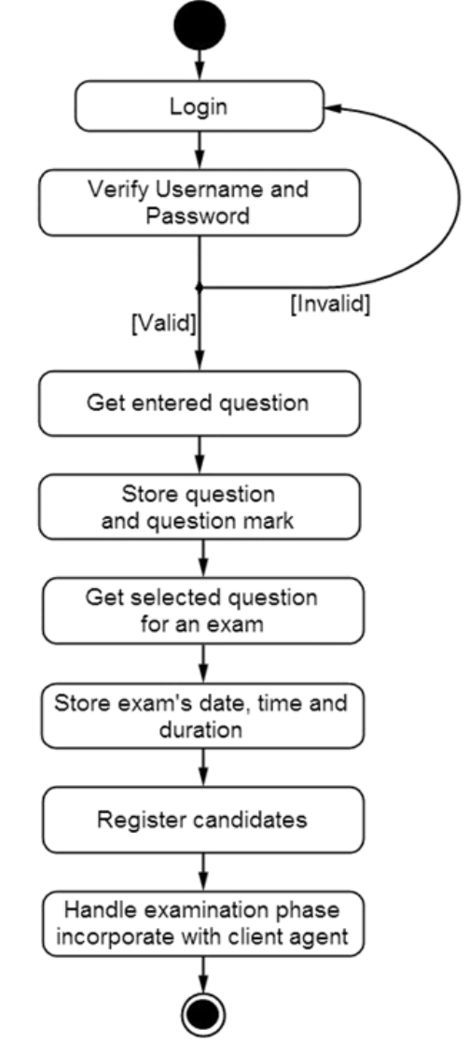

**Fig: Administrator working Flowchart**

* + 1. **Server Agent and Client Agent Flowchart:**

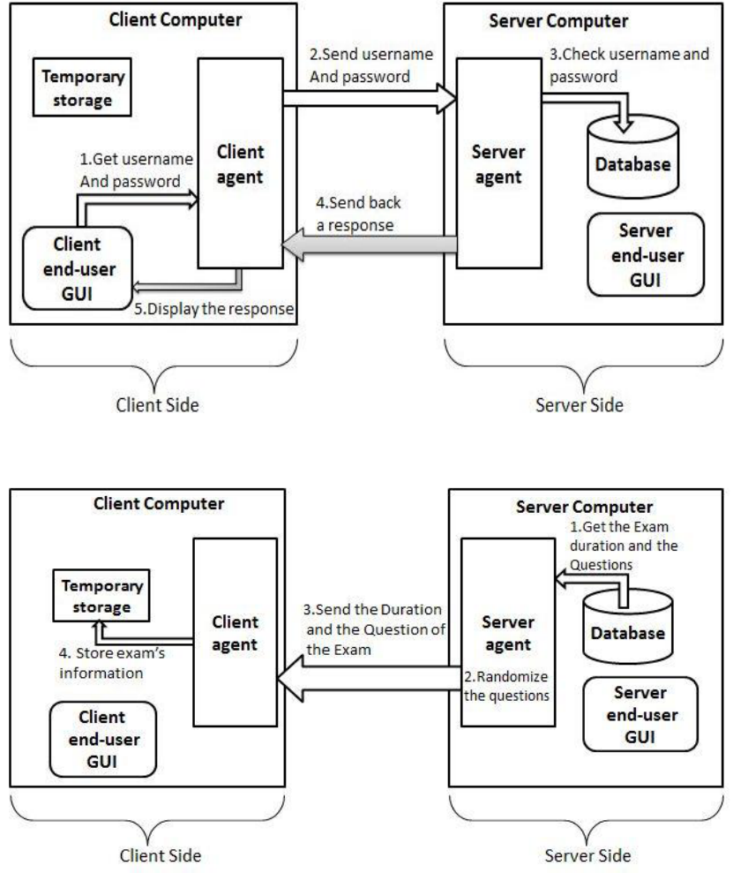

**Fig: Client Agent and Server Agent Flowchart**

**3.5.3 Student Profile Working Flowchart:**

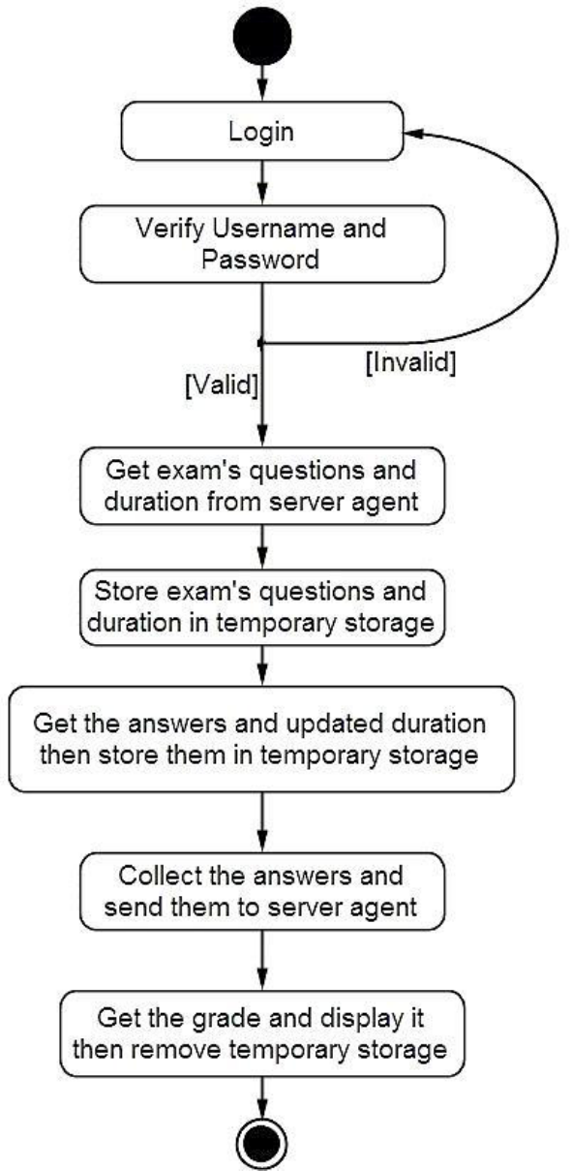

**Fig: Working Flowchart of Student Sector**

**3.5 Database Schema Diagram:**

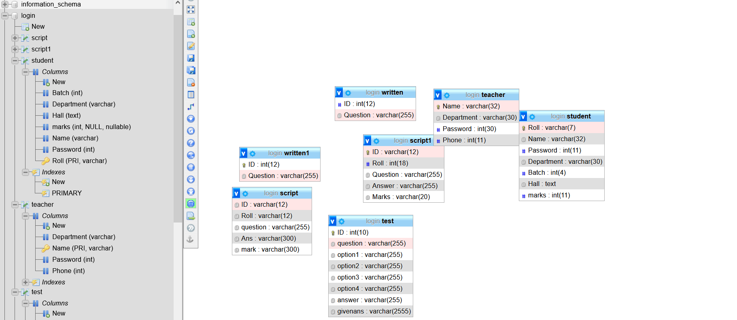

**3.5.1 Student Table:**

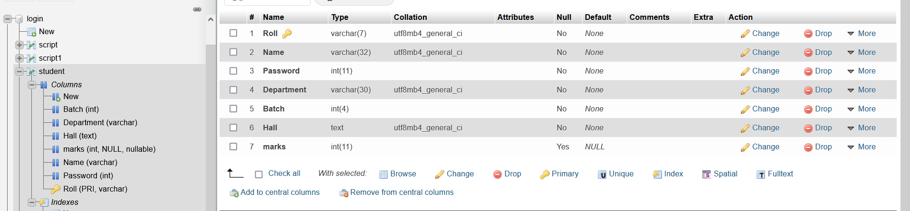

* + 1. **Teacher Information Table**

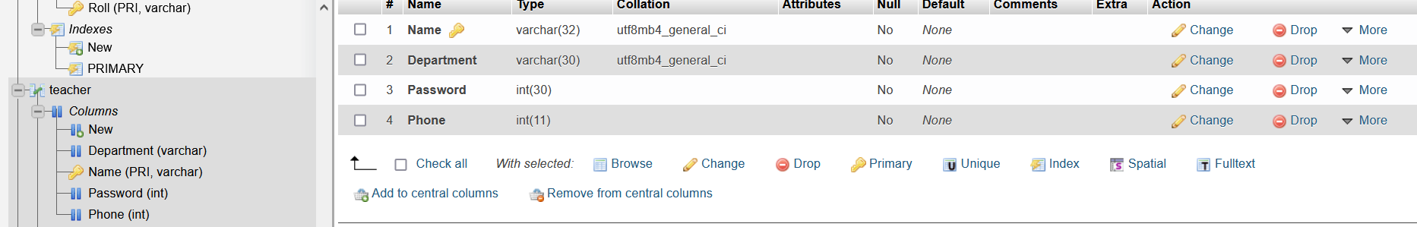

* + 1. **MCQ Test Question Table**

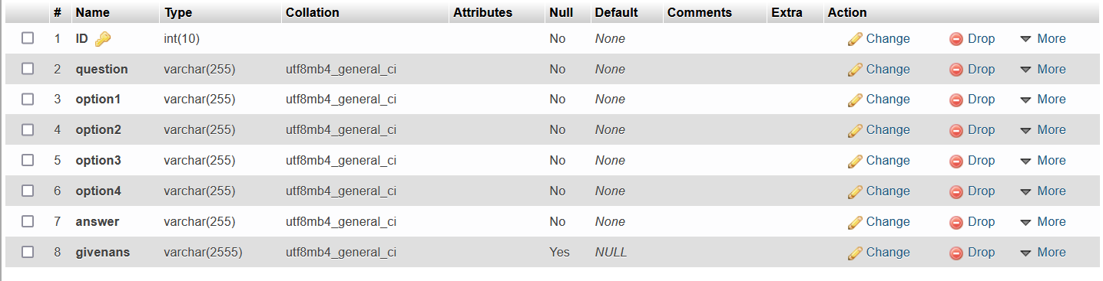

* + 1. **Written Question Table**



* + 1. **Written Test Table**

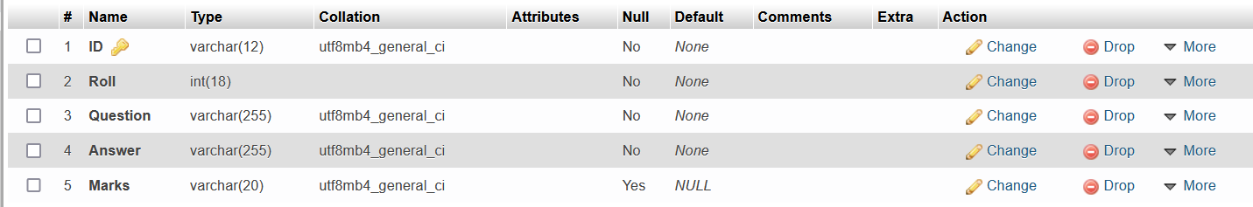

**4. Detailed Visualisation**

**4.1 Login and Registration page:**

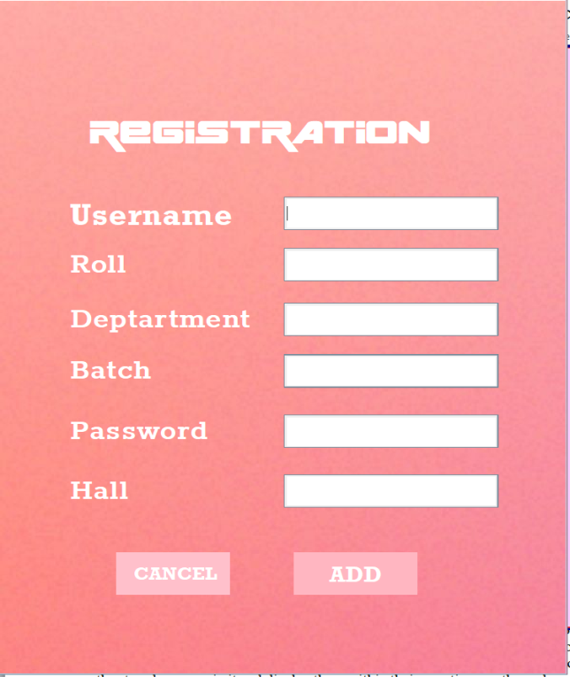

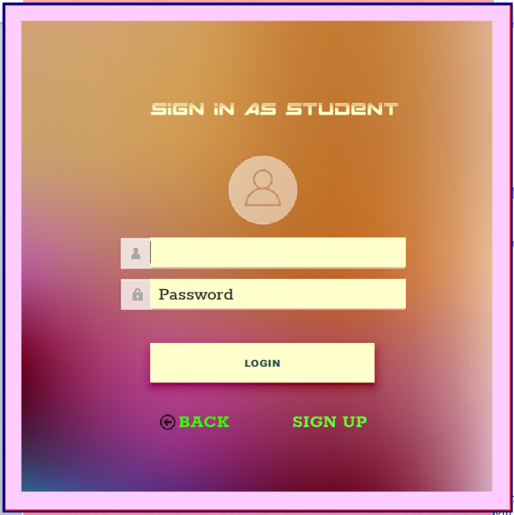

**4.2 Student profile:**

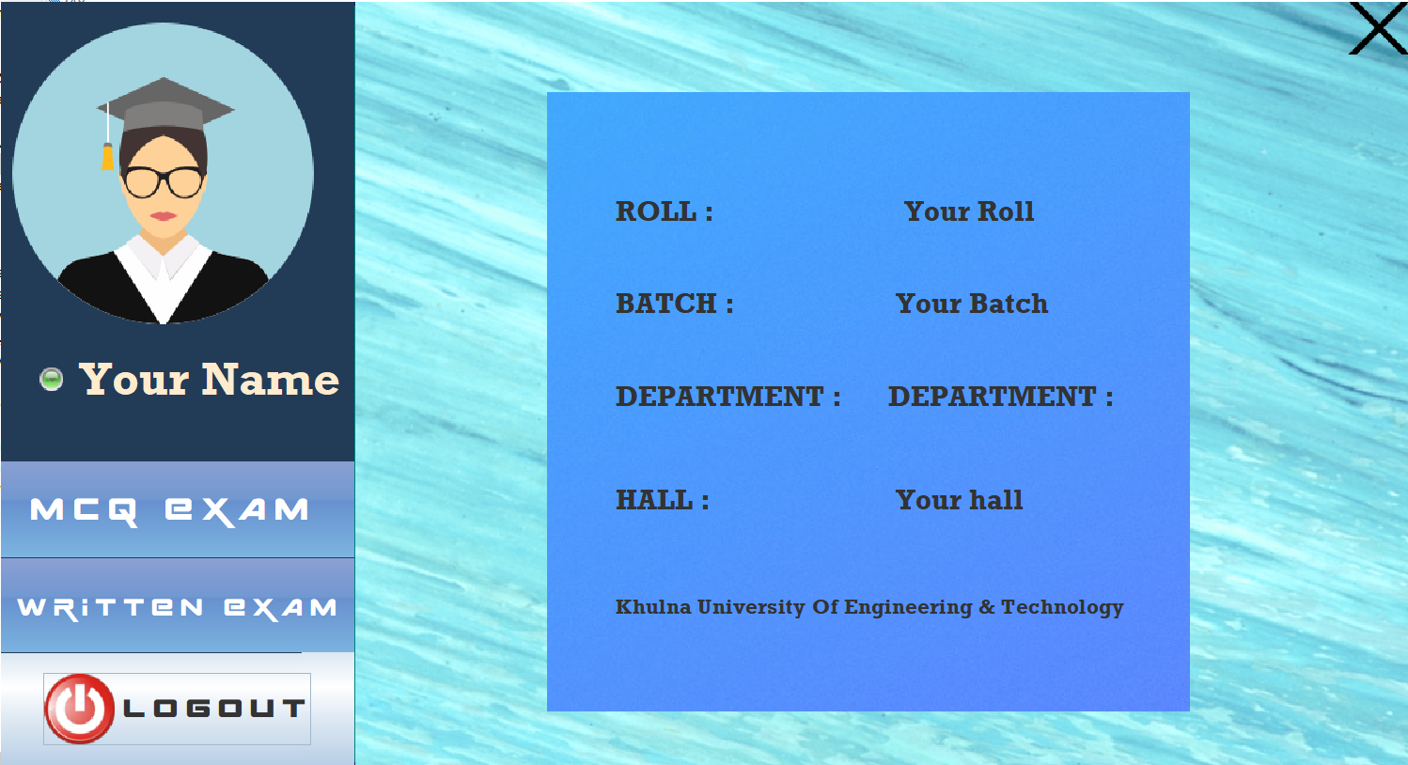

**4.3 Admin Panel Page:**

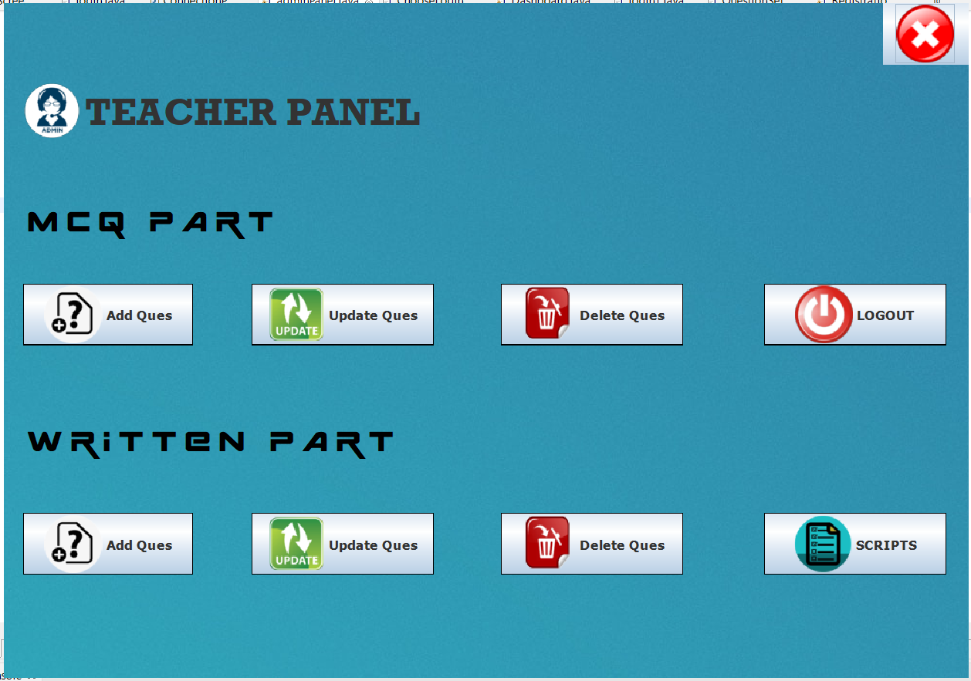

**4.4 MCQ Question Set page:**

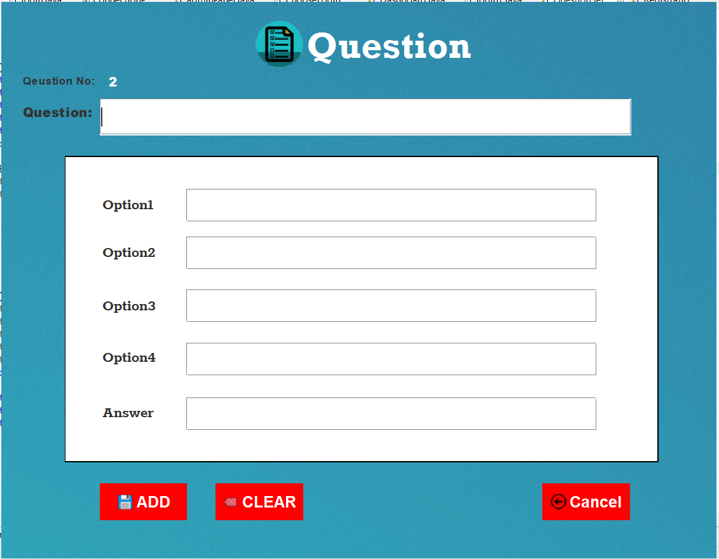

**4.5 : Written Question Set Page:**

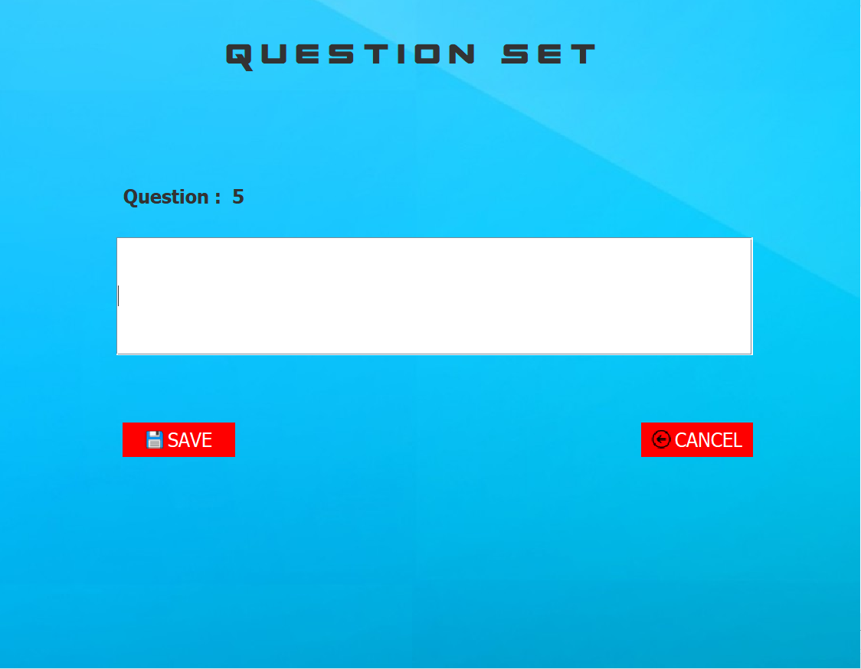

**4.6 Update Questions**

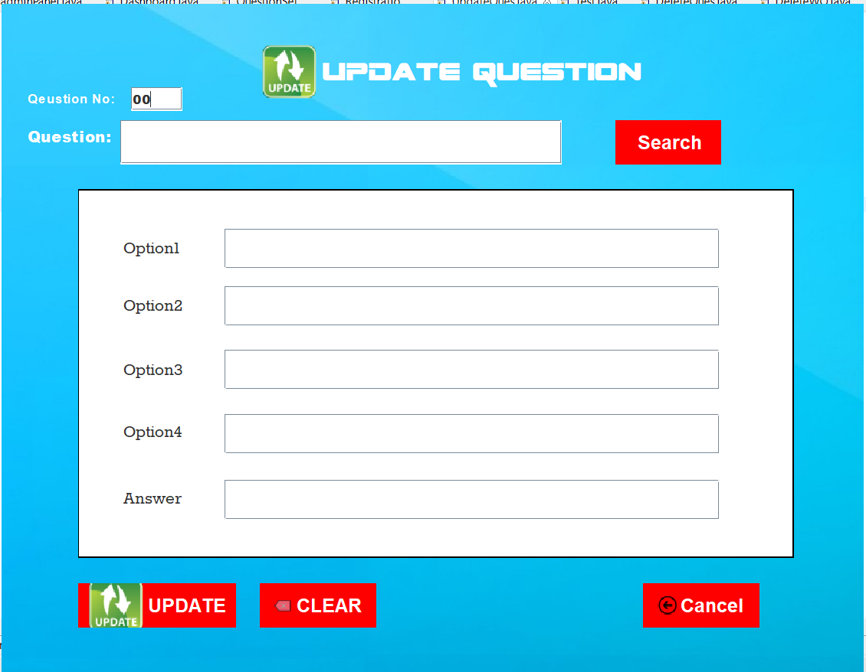

**4.7 Delete Questions:**

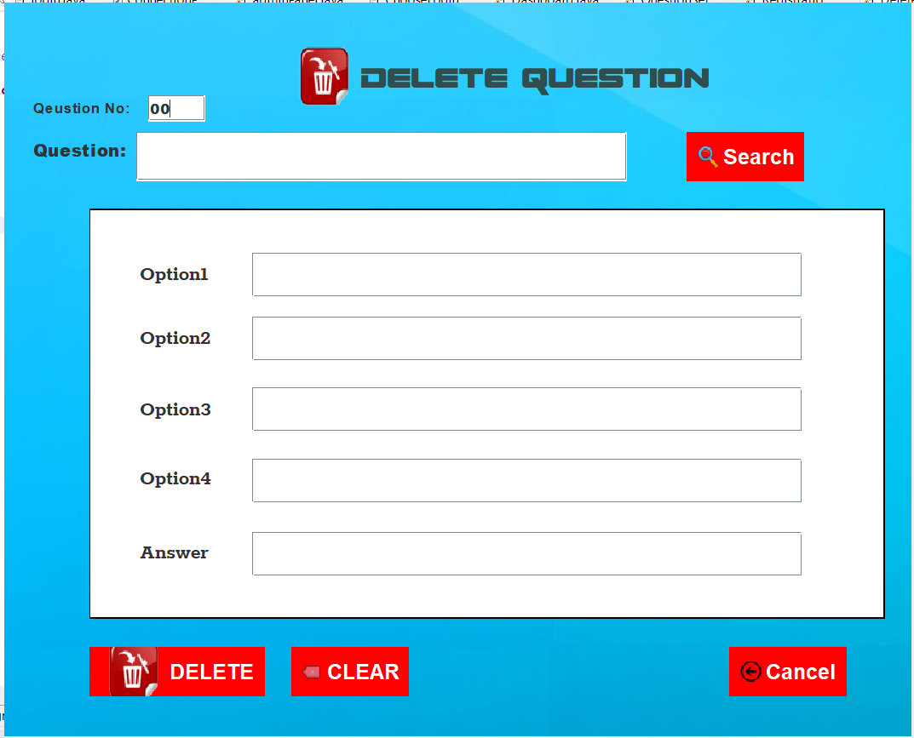

**4.8 Delete Written Question:**

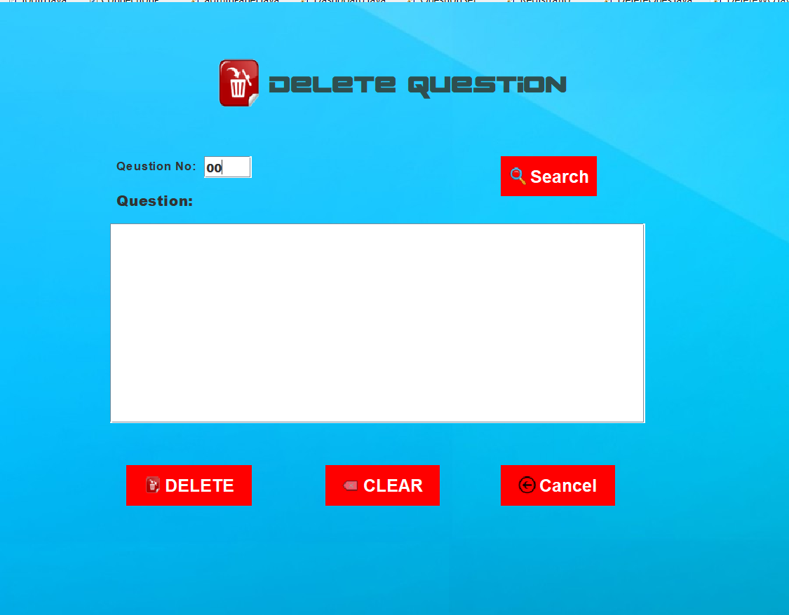

**4.9 Evaluate Script as admin**

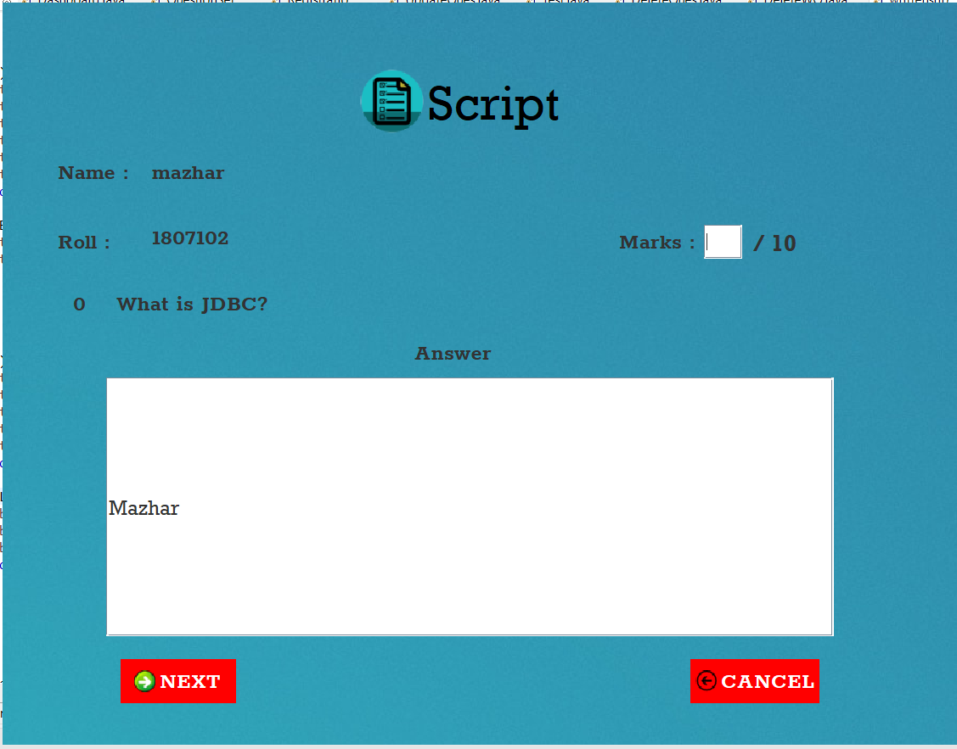

**4.10 Answering MCQ question and Get instant result:**

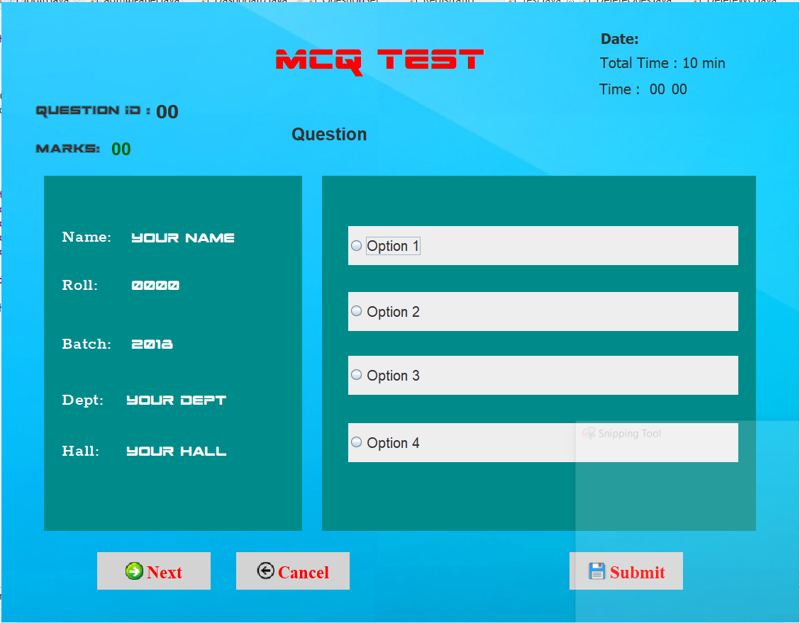

* 1. **Answering Broad Questions:**

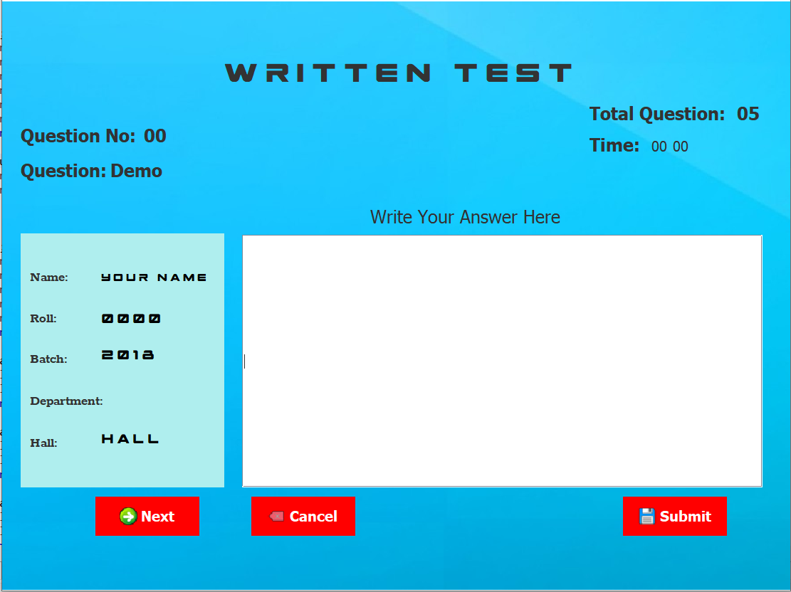

**5.Target vs Actual Accomplishment**

**5.1 Targets:**

The online examination system proposed in this study is designed using a layered architectural

pattern that has four layers - presentation, core modules (comprising of three modules), server, and storage service as depicted in Fig.1. Each layer is discussed in this section as follows.

**a. Presentation Layer**

This layer represents the various ranges of devices that can be used to access the online examination system via the Internet. This can include desktop machines, laptops, and mobile devices such as smart phones and tablets.

**b. Core Modules**

This layer refers to the key feature of the online examination system that is split into three modules. The Administrator module allows an authorized admin to add departments to the systems database. The Department module allows a given department to add examinations for the students to take. The Student module simply provides the interface for the students to take exams.

**c. Server**

This refers to the layer from which the online examination system can be deployed as a web application. Apache Webserver was the server used in this implementation and is reputed to be the most popular server.

**d. Storage Service**

This layer covers the rapid retrieval and storage of data and information using a Relational Database Management System. MySQL was the database adopted in this study and it works seamlessly with the Apache Web server.

**5.2 Actual Accomplishment:**

I’ve worked hard and tried as much as possible to do same as shown in targets. But as I worked with Localhost database sometimes database did not worked. The user Interface is not as much satisfying as I wanted, so I have to work more developing UI.

I want to add some more features:

i)Explanation Of questions.

ii) Some website link should be provided For particular questions.

iii) Student Profile Should be more Organised and They can add pictures of their own.

**6. Risk and Issues**

**6.1 Temporary Storage**

The temporary storage is a file created at the client side. The life cycle of the temporary storage file can be in one of the following states: create, update, and remove. The client agent creates this file in getting started phase automatically. The purpose of this file is to store exam’s information that received from the server agent namely: the questions of the exam and exam’s duration.

**6.2 Power Failure**

The client agent manages the OLES phases to be ready for the power failure. The procedure that the client agent takes for this management is after the login phase. The client agent checks the temporary storage whether it is created or not and if not then this is the first login of this student onto the system. Otherwise, there is a temporary storage file that means this login is happened after power failure situation. Subsequently, the client agent accesses the temporary storage, load the stored answers in it and display them within their questions on the end-user GUI. In addition, the time left of the exam is also stored in this temporary storage. Thus, the client agent loads the duration of the exam and the time left is still fixed no matter how long the power was off.

In the server side, the server agent manages the system phases to be ready for the power failure.

**6.3 Network Failure**

In case of network failure, the client agent and server tolerates it according to which phase this

failure is occurred. If a network connection failure is occurred during the client agent sending the student’s username and password and the login information lost as shown in Fig. 10, in this case, if this acknowledgement did not received due to the network connection failure, the client agent will inform the user to this failure, login information is kept with client agent until the failure repaired, then the client agent will reconnect and resend data for login and resume the protocol operation.

**More problems can faced:**

• It is not applicable for guest user.

• Required of a number of system for individual examination.

1. **RESULT AND DISCUSSION**

.I’ve work hard and have done my best. But I have faced some problems during doing my project. I’ve faced difficulties using some method such as java.util didn’t work for some unknown reason. At the beginning I have got stuck there and couldn’t use my desired features.

Then I did that with another manual logical codes. “RS2XML.rar” file was damaged and I have faced and massive error which I have recovered with so many hardship. I have worked much for developing UI of this Project . I do use some method like JFrame, Jlabel, JButton, JRadioButton, JPanel and so on using Java.swing.* header file. These methods have helped me to done my work more easily. Instead of some difficulties I Have abled to finish the project successfully and it works Efficiently than other similar project exists.

1. **CONCLUSION**

The “**Online Examination System**” implemented in this study could serve as a robust testing platform for students not just based on objective (multiple-choice questions) but also essay-type questions. Through this proposed system as well, students can be graded more fairly and objectively given that our approach implements a keyword match of the students’ submission against the marking guide set by the examiner. Expenditure on paper is reduced thereby saving cost to the academic institution and also protecting the ecosystem. Time saved from using the system can be used for more productive activities. As future work, the OES implemented in this study can integrate multi-lingua capabilities to make its features robust. In addition, the system needs to be tested and validated by the would-be users (students and examiners) so as to ascertain its usability. This will be the focus of further studies.

**REFERENCES**

1. A. Bloomfield, and J. F. Groves, A tablet-based paper exam grading system, ACM SIGCSE Bulletin, 40 (2008), 83-87
2. F. W. Brown, and A. Bielinska-Kwapisz, Understanding the Nature and Determinants of Critical Thinking Among Senior Business Undergraduate Students, Journal of Education for Business, 90 (2015), 359-368
3. M. Z. Islam, M. M. Rahman, and M. K. Islam, Online Examination System in Bangladesh Context. International Journal of Science, Environment and Technology (IJSET), 2 (2013), 351-359 .
4. Y. S. Kim, J. S. Oh, J. Y. Lee, and J. H. Chang, An intelligent grading system for descriptive examination papers based on probabilistic latent semantic analysis. In AI 2004: Advances in Artificial Intelligence (2004) 1141-1146 .
5. M. Z. Rashad, M. S. Kandil, A. E. Hassan, and M. A. Zaher, An arabic web-based exam management system. Int. J. of Elect. and Comp. Sci. IJECS-IJENS, 10 (2010), 48-55
6. R. Sheshadri, T. C. Reddy, and N. A. Kumar, Web-based-secure online non-choice–based examination system (wones) using cryptography, Journal of Discrete Mathematical Sciences and Cryptography, 15 (2012), 353-368
7. R. Sjöstedt, Assessing a broad teaching approach: the impact of combining active learning methods on student performance in undergraduate peace and conflict studies. Journal of Political Science Education, 11 (2015), 204-220
8. V. C. Wang, and G. Torrisi‐Steele, Online Teaching, Change, and Critical Theory. New Horizons in Adult Education and Human Resource Development, 27 (2015), 18-26
9. Y. Wu, W. Zhao, X. Peng, and Y. Xue, A computer aided grading system for subjective tests. In Telecommunications, 2006, AICT-ICIW'06. International Conference on Internet and Web Applications and Services/Advanced International Conference on (2006) 2-7